Module 4, Critical Thinking, Option #1: Implementing SAS Hypothesis Testing
Christopher J. Weller
Colorado State University – Global Campus

Introduction
Students sometimes participate in tutoring to improve their performance. This tutoring should be reviewed to ensure it is having a positive effect on their scores.
The following study tracks twelve students, and measures their scores before and after tutoring. This data is then feed into a SAS program, and then analyzed with the screen shots of that analysis shown below. The hypothesis is that the tutoring will improve their scores, and the following tests will either support that thesis or not.

Screen Shot of the Code


Screen Shot of Logs, Part 1 of 3
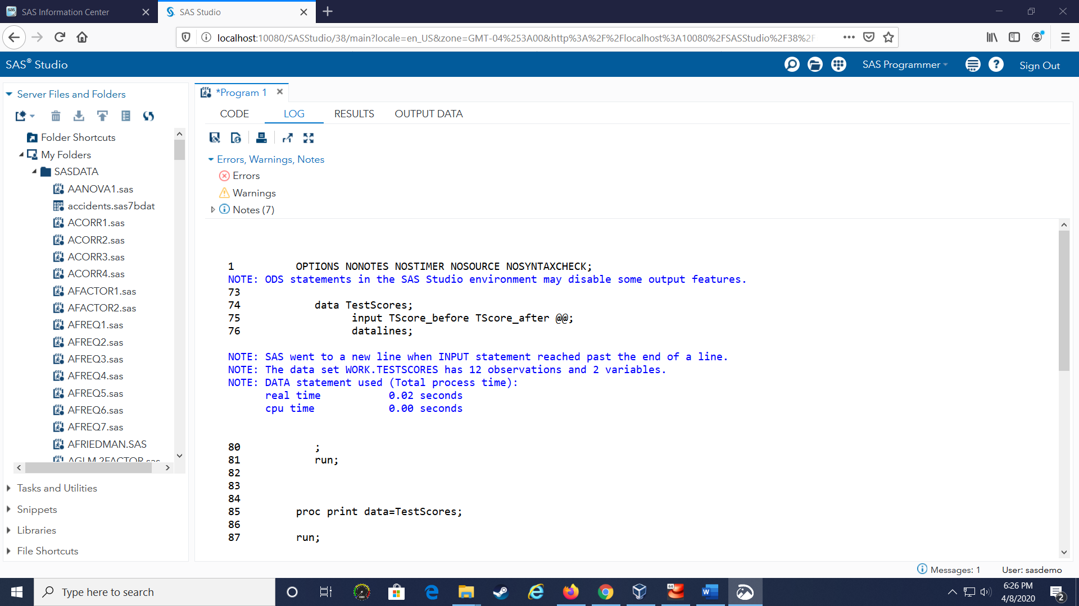

Screen Shot of Logs, Part 2 of 3

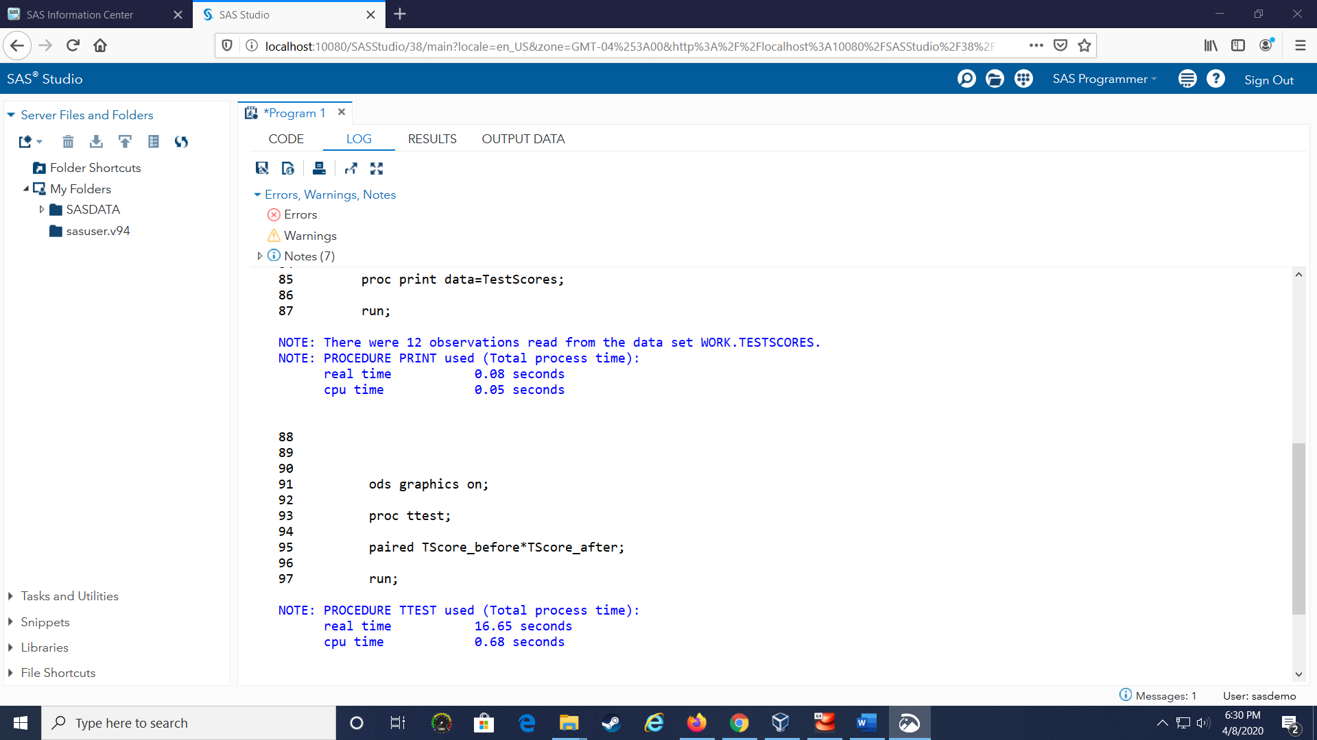

Screen Shot of Logs, Part 3 of 3
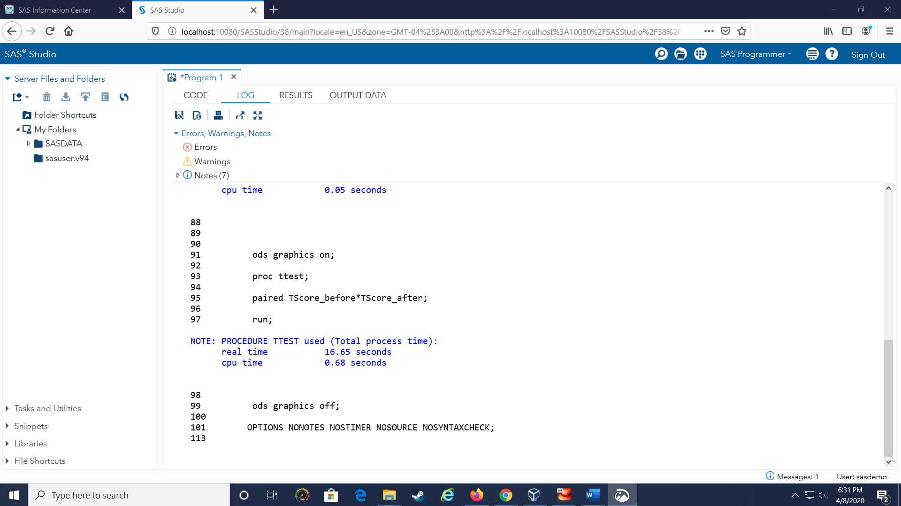

Screen Shot of Results, Part 1 of 5
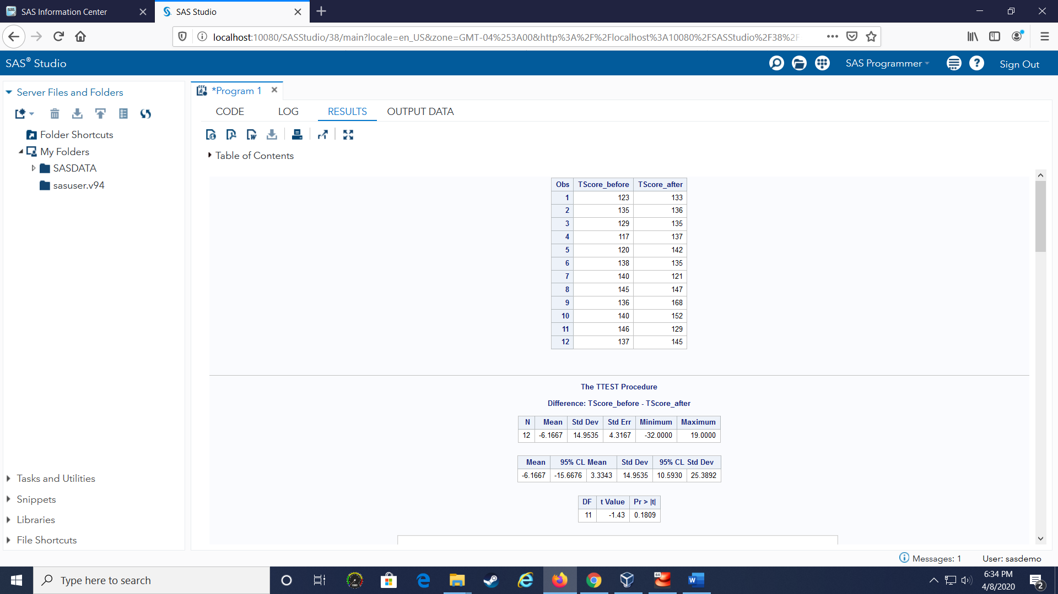

Screen Shot of Results, Part 2 of 5

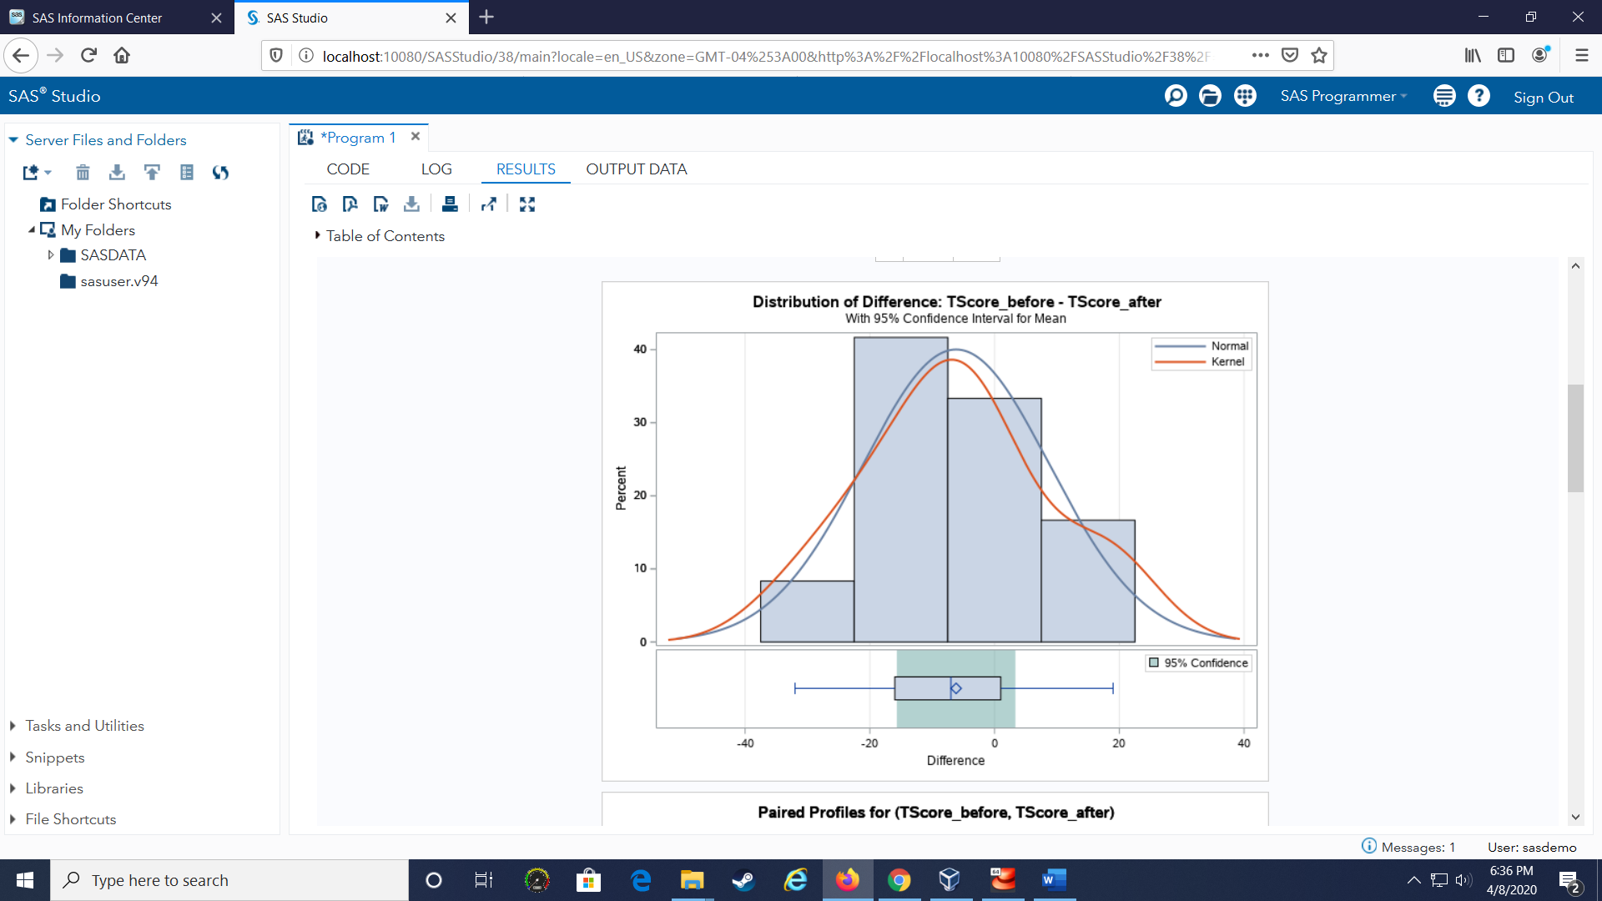

Screen Shot of Results, Part 3 of 5
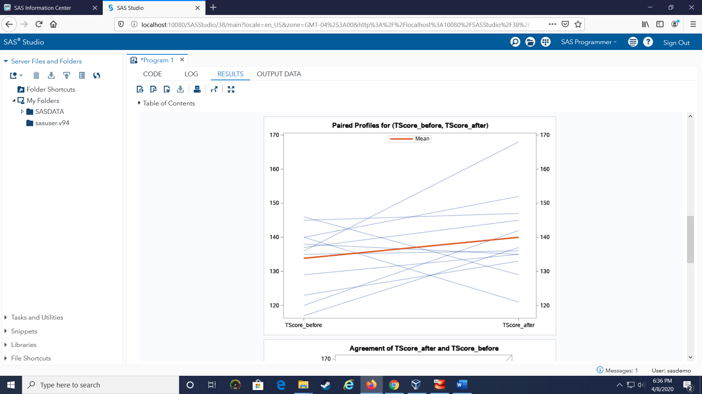

Screen Shot of Results, Part 4 of 5
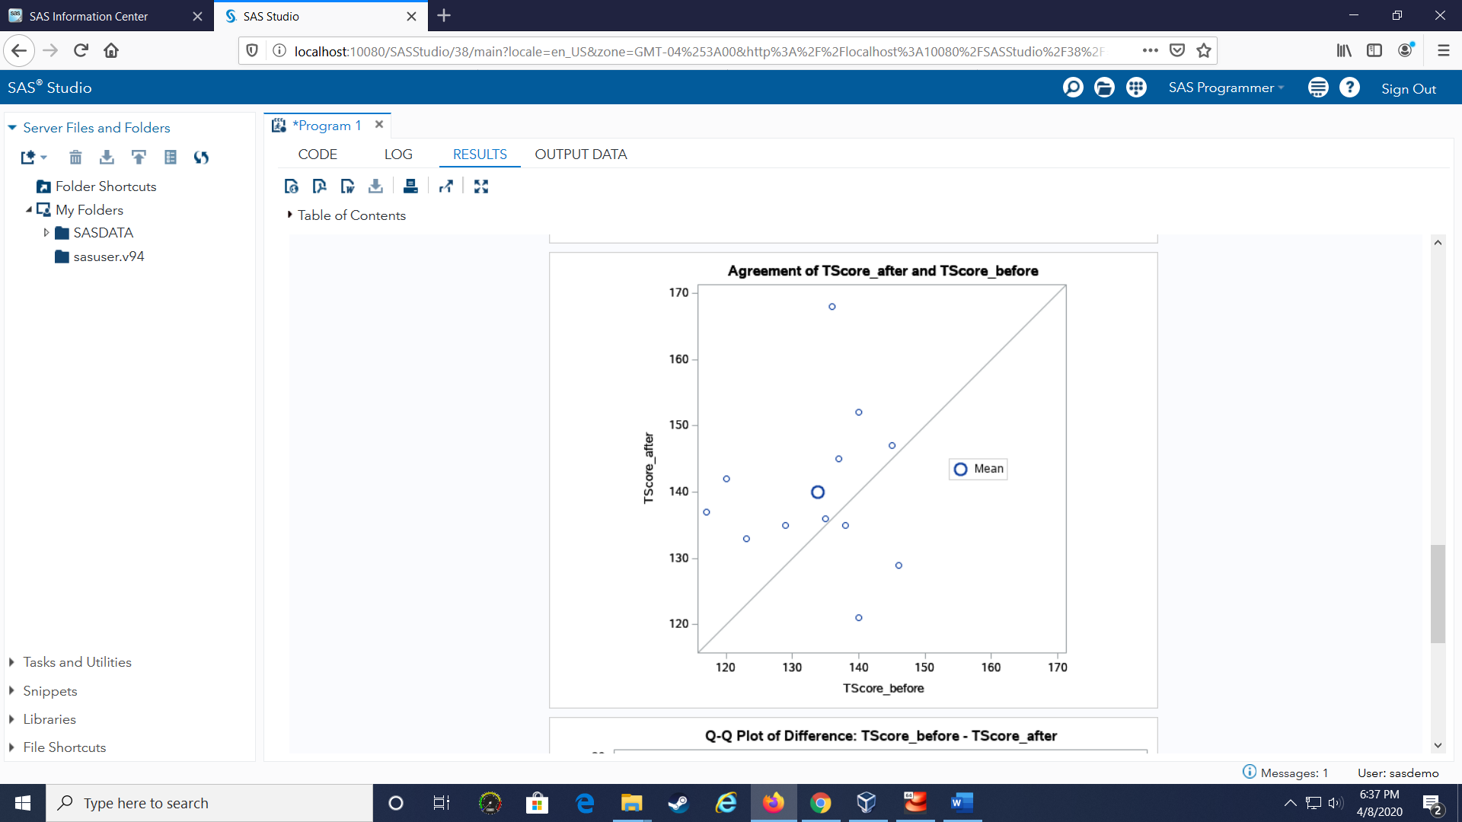

Screen Shot of Results, Part 5 of 5 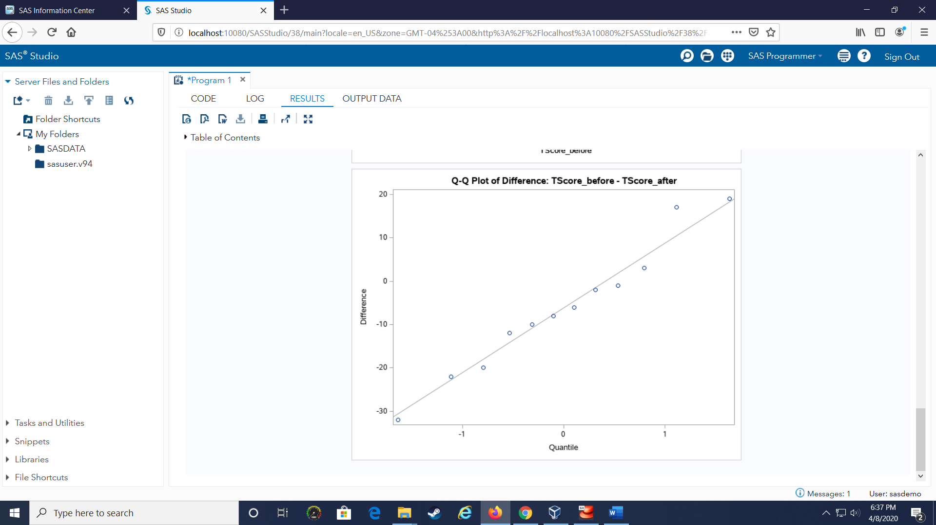

Output Data
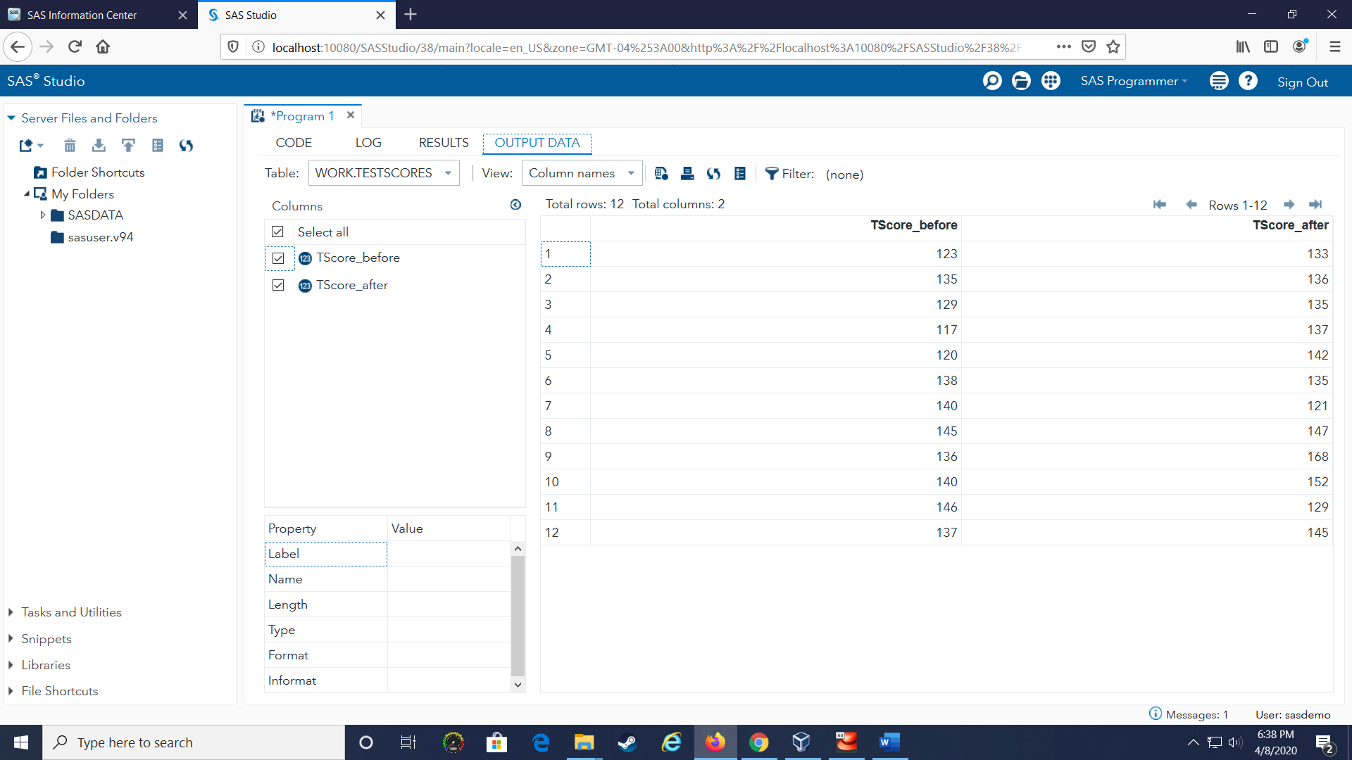

Results
As shown in the screenshots above, there appears to be a positive relationship between a student receiving tutoring and the student getting a higher score. First, the summary data shows 8 out of 12 students improved their score after tutoring, with 1 student’s score staying the same, and 3 students’ scores becoming worse. Second, the average (mean) improvement of the student’s scores was 6.1. Third, the Paired Profiles, Agreement, and Q-Q Plot of Differences Charts all show a positive upward relationship. These 3 tests all support the hypothesis that tutoring improves the scores.
With that said, the 95% Confidence Interval is showing -3.3 to 15.6 improvement. This shows that while it is likely that tutoring is beneficial, we do not have 95% confidence that tutoring is beneficial. Given the current data, there is a chance at the 95% Confidence Level that tutoring has a positive effect (above 0 to 15.6 improvement), or no effect (0 improvement), or even a negative effect (below 0 to -3.3 improvement). This data does not strongly support the hypothesis that tutoring improves the scores.
Conclusion
Twelve students were tracked to see if tutoring would improve their scores. While there is a positive improvement of ~6 points on average, further analysis is needed to increase the confidence that tutoring leads to a positive improvement. Two ways to improve the next analysis is to include a control group (e.g. track students who do not receive tutoring) to ensure that the improvement is attributable to tutoring, and not another factor (e.g. 8 students received additional homework which resulted in better scores), and to increase the number of students tracked (e.g. thirty students instead of twelve) that would lead to a narrower 95% Confidence Level Interval.

